**NAME : SAURABH SANTOSH PATIL**

**PRN : 2020BTECS00031**

**BATCH : S3**

**SUB:COA lab**

**< PRACTICAL no.11>**

**Title of experiment**:

Wap for arranging numbers in ascending and

descending order

**Equipments required**:

**Gnu simulator**

**Theory:**

**For ascending order:-**

**1) Initialize HL pair as memory pointer.**

**2) Get the count at 4200 in to C register.**

**3) Copy it in D register.**

**4) Get the first vale in Accumulator.**

**5) Compare it with the value at next location.**

**6) If they are out of order, exchange the contents of accumulator and memory.**

**7) Decrement D register’s content by 1.**

**8) Repeat steps 5 and 7 till the value in D register become zero.**

**9) Decrement C register’s content by 1.**

**10) Repeat steps 3 to 9 till the value in C register becomes zero.**

**11) Terminate the program.**

**For descending order:-**

**1) Initialize HL pair as memory pointer.**

**2) Get the count at 4200 in to C register.**

**3) Copy it in D register.**

**4) Get the first vale in Accumulator.**

**5) Compare it with the value at next location.**

**6) If they are out of order, exchange the contents of accumulator and memory.**

**7) Decrement D register’s content by 1.**

**8) Repeat steps 5 and 7 till the value in D register become zero.**

**9) Decrement C register’s content by 1.**

**10) Repeat steps 3 to 9 till the value in C register becomes zero.**

**11) Terminate the program.**

**Program code:**

**;Arrange in ascending order**

**LDA 1100**

**MOV B,A**

**DCR B**

**LOOP3: LXI H,1100**

**MOV C,M**

**DCR C**

**INX H**

**LOOP2: MOV A,M**

**INX H**

**CMP M**

**JC LOOP1**

**MOV D,M**

**MOV M,A**

**DCX H**

**MOV M,D**

**INX H**

**LOOP1: DCR C**

**JNZ LOOP2**

**DCR B**

**JNZ LOOP3**

**HLT**

**;Arrange in descending order**

**;Arrange in descending order**

**LDA 1100**

**MOV B,A**

**DCR B**

**LOOP3: LXI H,1100**

**MOV C,M**

**DCR C**

**INX H**

**LOOP2: MOV A,M**

**INX H**

**CMP M**

**JNC LOOP1**

**MOV D,M**

**MOV M,A**

**DCX H**

**MOV M,D**

**INX H**

**LOOP1: DCR C**

**JNZ LOOP2**

**DCR B**

**JNZ LOOP3**

**HLT**

**Snapshots:-**

**For ascending order:-**

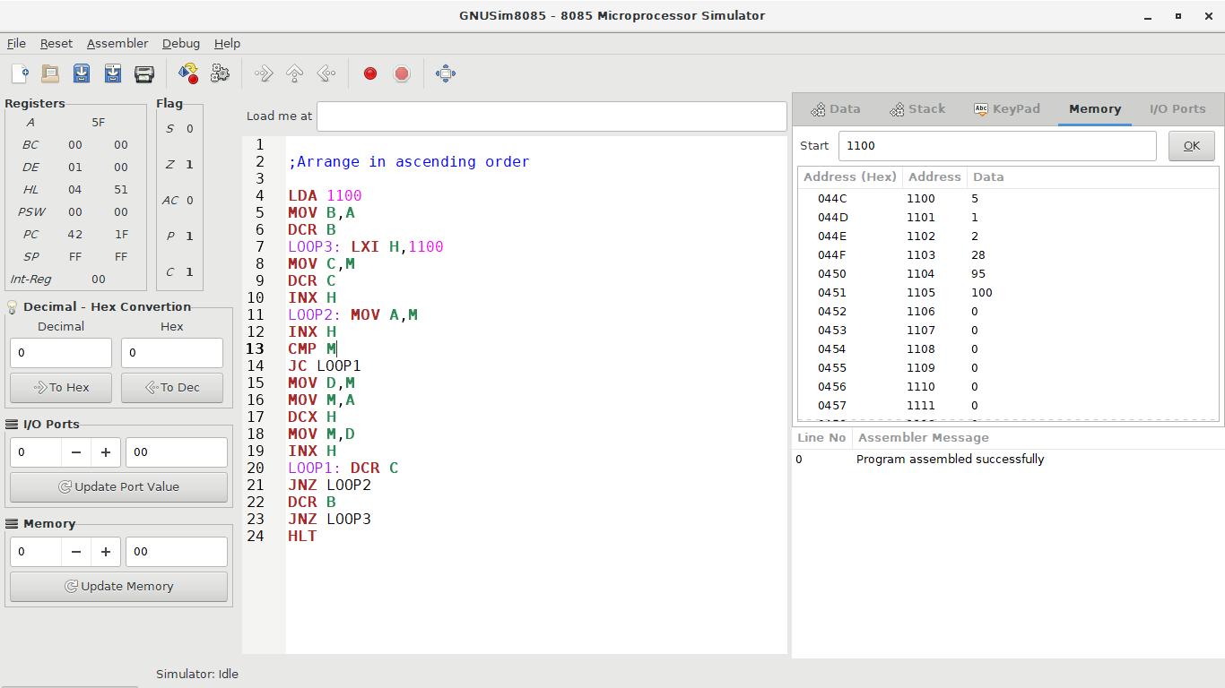



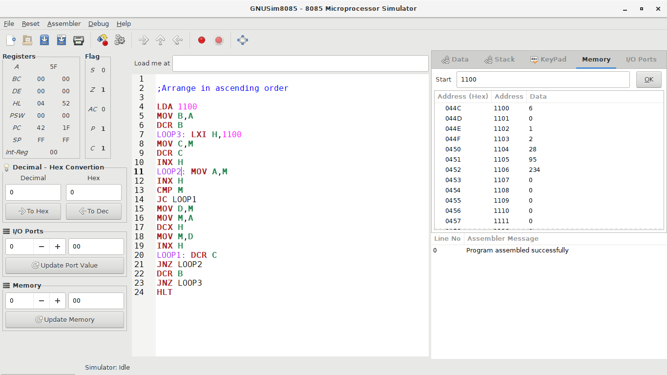



**For descending order:-**

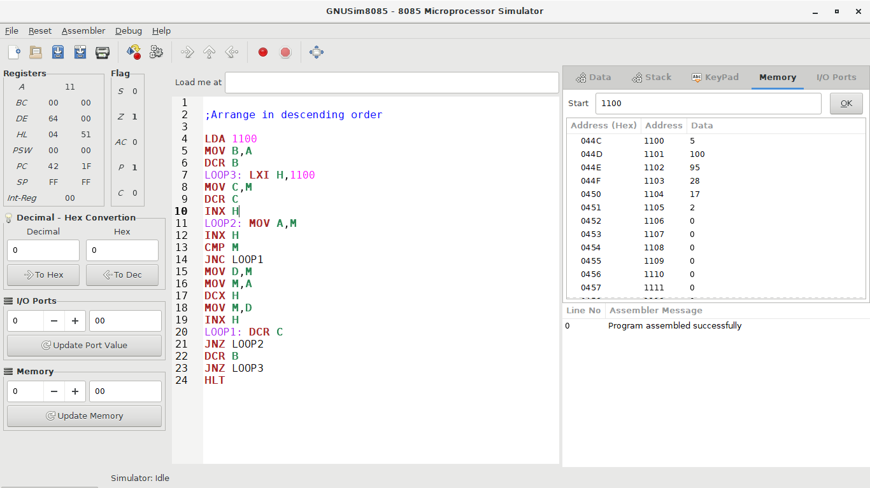



**Conclusions:**

**These are ways to perform ascending and descending order**